**Danang International Fireworks Festival**

On the afternoon of November 8, 2018, Standing Vice Chairman of the City People's Committee Dang Viet Dung worked with relevant units on the plan to organize the Danang International Fireworks Festival (DIFF 2019) which will take place in 5 nights, from June 1 to July 6, 2019.

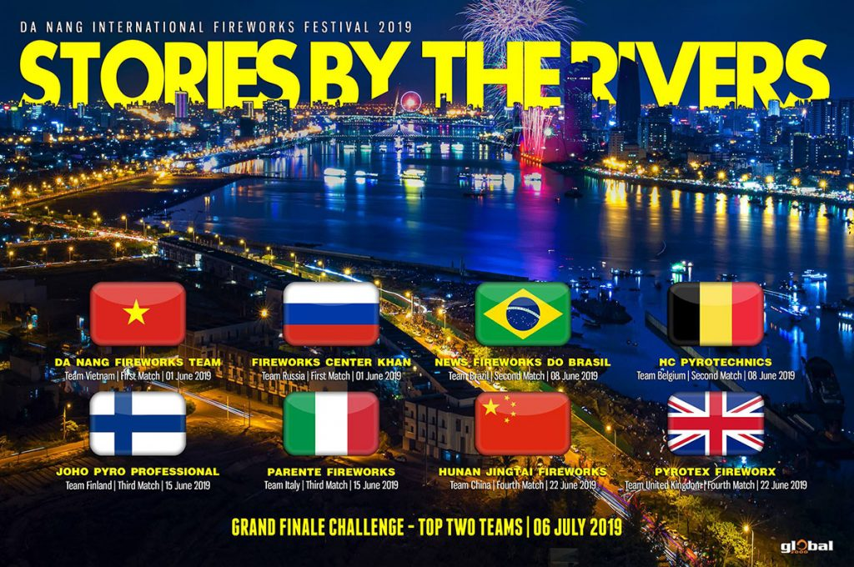

According to the draft plan of the city's Department of Culture and Sports, the DIFF 2019 event is still performed by the Sun Group Joint Stock Company, and the Global 2000 Company is the performance consultant. The expected theme of DIFF 2019 is 'Rivers that tell stories' with the participation of 8 international fireworks teams including: Vietnam, Russia, Brazil, Belgium, Finland, Italy, China, England.

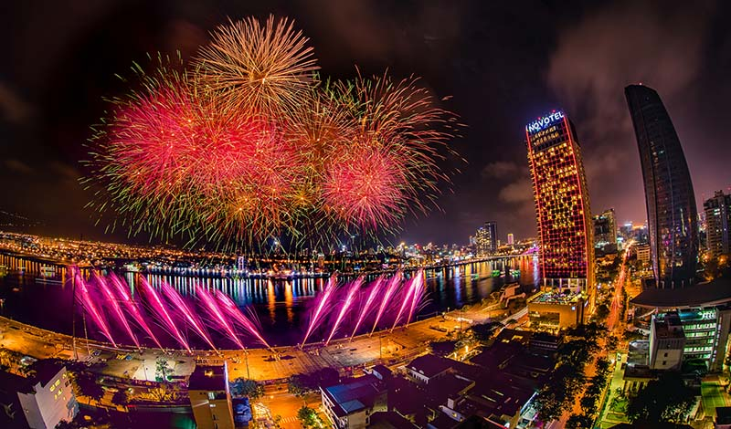

The location of the fireworks display is the Han River port area. The main stand and stage are the sidewalk area of ​​Tran Hung Dao street. DIFF 2019 will innovate a number of auxiliary activities such as: organizing a national Flasmob dance competition with a preliminary round at 4 specific points across the country and a final in Da Nang; The proposed plan also offers a plan to organize a street festival; assigning tasks to relevant departments, departments, agencies, units…

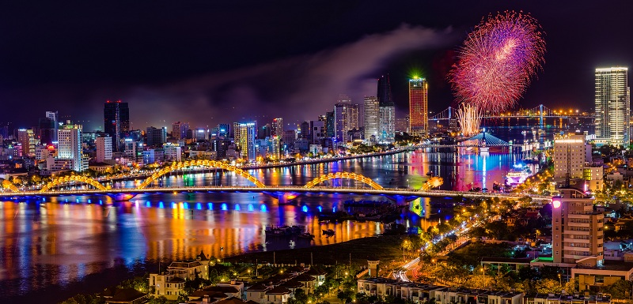

On the topic of each night, Standing Vice Chairman of the City People's Committee Dang Viet Dung said that the participating teams should be allowed to tell their own stories, about their country. Particularly, the final night should choose a common theme and must be featured after 10 years of Da Nang organizing fireworks.

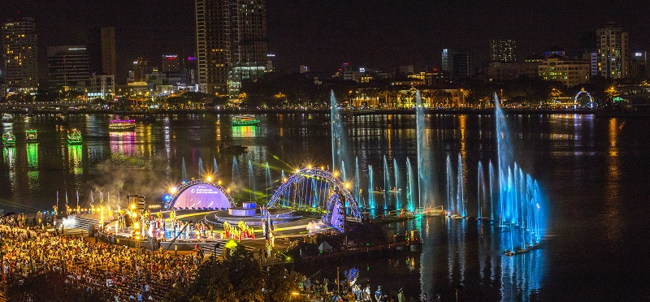

Standing Vice Chairman of the City People's Committee Dang Viet Dung also mentioned that when organizing accompanying events, it must be associated with the brand of Da Nang.

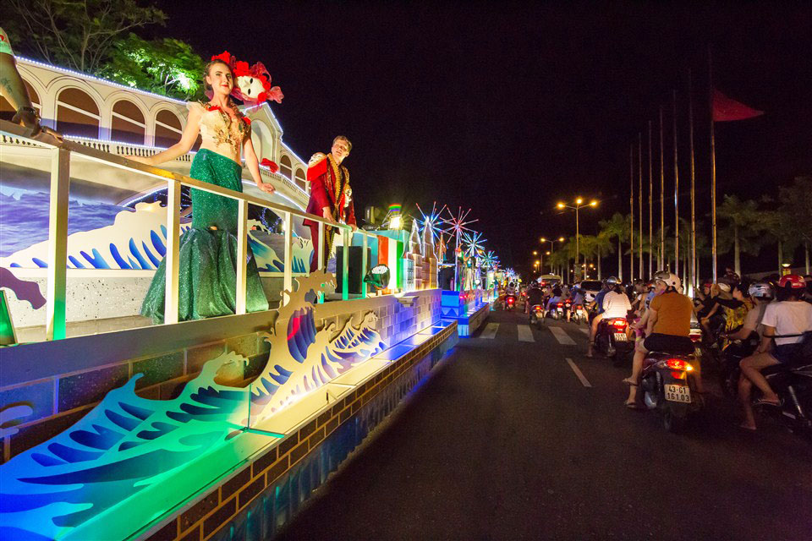

Street festival activities must choose an appropriate plan to attract a large number of people and tourists to participate so that DIFF 2019 must become a festival of the whole community. Standing Vice Chairman of the City People's Committee Dang Viet Dung also noted that the Department of Culture and Sports needs to develop a festival program for 2019 and announce it soon for everyone to know. According to baodanang.vn – Danang International Fireworks Festival 2019 will take place in 5 nights, from June 1 to July 6, 2019.